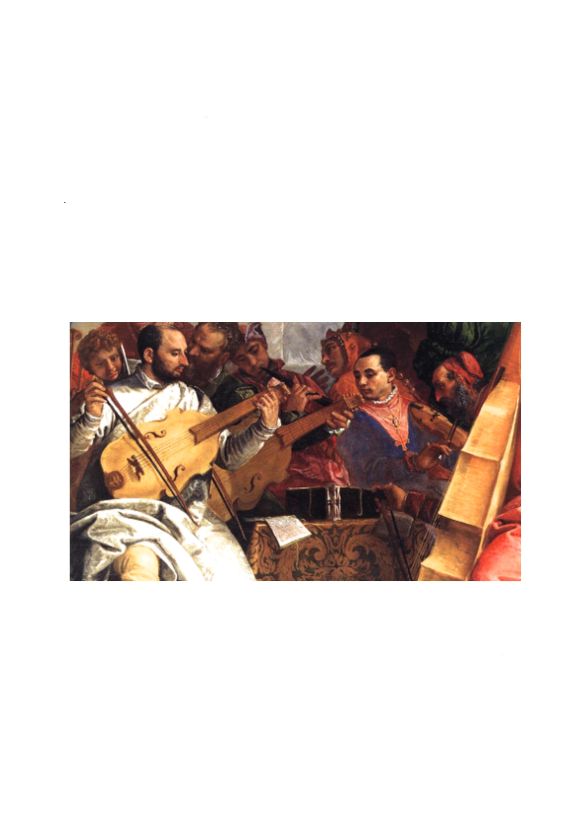
labyrinth
a concert
for two viols and harpsichord
Richard Boothby, Lucy Robinson,
Andrew Wilson-Dickson

Sunday 23rd November, 3pm

Canton Uniting Church
Theobald Road/ Cowbridge Road East, CF5 1LQ

music by Couperin, Marais, Forqueray, CPE Bach
and Andrew Wilson-Dickson

Suggested donation for entry: £10 adults/ £5 full-time students. Supporting CUC building fund. more details at cantonuniting.org.uk

